

**Agent-Based Modeling Report: NetLogo reproduction model based on financial variables**

**Professor: Soung Ryong Yee**

**Student: Ericka Bermudez  
Student ID: 202230093  
  
Date: 16/06/2022**

Index

Abstract

Background

1. Introduction

1.1 Explanation of base model

1.2 Purpose and goal

2. The model

2.1 Explanation of the model

2.2 Model verification

2.3 Other

3. Simulation Analysis

3.1 Explanation of the simulation

3.2 Explanation of the result

3.3 Analysis of the result

4. Conclusion

5. Reference

6. Appendix

This report intends to describe the model built for the class of Agent-Based Modeling. First, a short description of the model and the background will take place, and then the model and the experiments performed will be described in detail.

# **Abstract**

In developed countries there is a rising concern about the decline in fertility rates. Total Fertility Rate (TFR), and thus the birth rate, is one of the most important measures in demography, as its relevance affects government policies and the general well-being of the population [12]. One of the reasons for this concern is the replacement level of fertility, The birth rate in most of the countries in the developed world is no longer sufficient to maintain the current population [4].

Considering the importance of TFR, a NetLogo model is created to address the decaying TFR in developed countries. The model is based on financial factors and how they impact the decision of the agents to reproduce. Based on the results, I conclude that financial insecurity is an important factor in the decline of birth rates in developed countries or urban areas, and can produce similar results to those of real life, but cannot alone replicate the decision process of this complex social issue.

# **Background**

Birth rate is the number of individuals born in a population in a given amount of time. Human birth rate is stated as the number of individuals born per year per 1000 in the population. For example, if 35 births occur per year per 1000 individuals, the birth rate is 35 [4]. Fertility rate or TFR, a concept that will be used frequently in this report, accounts for the number of children per average mother [4]. A sustained TFR lower than the replacement level would have economic, social, environmental, and geopolitical consequences [7].

Common sense could say that the replacement level fertility is 2.0, that is, each couple that has babies will replace themselves when they pass away. But actually, the rate is 2.1 children per woman. This extra 0.1 addresses the statistic that when a baby is born there is an extra 5% chance that it will be a boy and 1% of women that don’t live past the age of 49, rounded [12]. This number is higher in countries with high mortality rates, but they are not the subject of this report.

The reason this model will address developed countries and not developing countries is that in developing countries children are needed as a labour force and to provide care for their parents in old age. This is, there is an economic incentive to have children, instead of only being associated with a cost. In these countries, fertility rates are higher due to the lack of access to contraceptives and generally lower levels of female education.

# **1. Introduction**

In this section, there will be explanations about the model and the goals of creating it.

## **1.1 Explanation of base model**

Although the model concept was not found in any base models, there were models that behave similarly to our goal, and thus can be called our base models. First, the HIV model [22] can be found in NetLogo’s model library. we can observe the model in Figure 1.1, as per the model description, it simulates the spread of the human immunodeficiency virus (HIV), via sexual transmission, through a small isolated human population. It, therefore, illustrates the effects of certain sexual practices across a population.

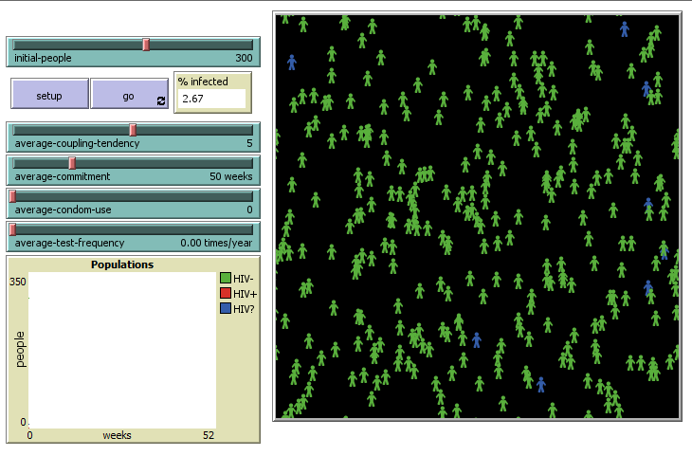

Figure 1.1 HIV Model

In this model, it exists a procedure for virus transmission that involves agents coupling. This coupling behaviour was then adapted and introduced in our TFR model. Another model with interesting procedures for TFR model was the Simple Birthrates. In Simple Birthrates, we can explore the size of a population-based on different birth rates. Here we can see a hatch behaviour that gave inspiration for the one in the model.

## **1.2 Purpose and goal**

Whether by choice or by circumstance, birth rates have declined significantly over the last 40 years. In the United States, the percentage of women who have not given birth by their 40s has nearly doubled since 1976, when 10 per cent of women had never given birth by their 40s [2]. Research by sociologist Kristin Park revealed that childfree people tended to be better educated, be professionals, live in urban areas, be less religious, and have less conventional life choices [18].

This model works under the hypothesis that these factors are correlated to the main factor: financial insecurity. A lot of women and men cite their reason not to have children as financial [13], and if we observe some financial statistics we can see a relationship between the cost of living and TFR.

For example, in the US, housing priced at $100,000 in 1967 is $953,910.69 in 2022. In other words, housing costing $100,000 in the year 1967 would cost $953,910.69 in 2022 for an equivalent purchase [14]. However, yearly earnings have not had the same kind of increase making it more difficult for people to acquire a house [21]. Research by [5] has concluded that, indeed, short-term increases in house prices lead to a decline in births among non-owners and a net increase among owners, as observed in figure 1.2.

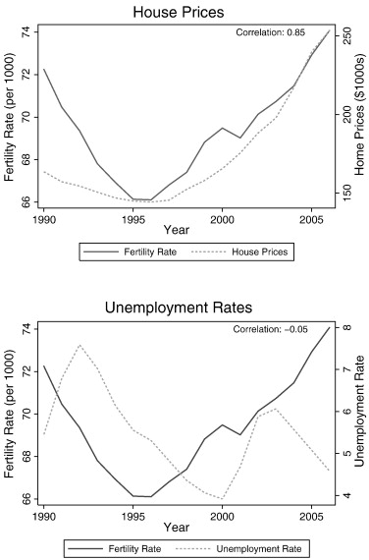

Figure 1.2 Similar behaviour can be observed in fertility rate and house prices [5]

Similar behaviour can be seen in other goods, making the costs of living outrank the annual earnings of the population. Financial insecurity has been addressed as a factor contributing to the declining birth rates by other sociologists [6], including increased unemployment, financial losses and economic uncertainty.

Seeing the relationship between house prices and fertility rate, and the strong sociological background, I believe an Agent-Based model would help to address financial insecurity in a clear fashion, taking into account more attributes related to birth rate to replicate and then predict the course of TFR in upcoming years, using a dynamic interface to reproduce real-time changes based on possible policies. The goal is, then, to address financial insecurity as a reason people decide not to have children. I hope to observe how financial measures can determine the number of births in one community and see a similar pattern to the one in real life.

# **2. The model**

The model is about TFR based on financial factors. In this section, I will explore the model.

## **2.1 Explanation of the model**

The agents in the model are humans, divided into two genders. Each agent posses attributes. The attributes are: coupled, partner, age, sex, annual earnings and children. Coupled refers to a boolean that addresses if the agent is currently in a couple. If the agent isn’t, it will be free to couple. If the agent does, their partner will be saved in the partner attribute, which otherwise will be nobody. Children is a number that refers to the quantity of children the agent currently possesses.

In the environment, that is the community the humans live in, there are two associated costs: living and having a child. There is also inflation and income increase, as a median annual income. Median annual income is used instead of the average annual income, as it is a more robust and accurate measure since it is not affected by a small number of extremely high or low-income outlier households [15]. The environment also possesses lifespan (the age at which an agent will die), maturity age (the age an agent can start to reproduce), percentage of women that don’t want to have children, and an ideal quantity of children.

Coupled agents will constantly evaluate their combined income against the costs of living and having children. The income increase and inflation can be changed at any point during the experiment, and the agents will react to this change.

During each time step, the following events will happen:

1. Check if the age of the turtle (agent) is more than the lifespan of the environment. If it is, it will die. Dying will mean decoupling if coupled. Else, the process will continue.
2. If the agent does not have a partner, the turtle (agent) will move in a random direction.
3. If there is a turtle in the spot it moved to, it will check if the turtle is of the opposite check and of reproductive age. If these two conditions are met, they will become a couple.
4. If the turtles are a couple, they will decide whether to reproduce, based on their combined annual income and the costs associated with living and having a child. If positive, the probability will take into account the turtle of the “female” turtle’s age for the conceiving rate [23] and the number of current children.
5. The age of the turtles, annual income and costs will be increased each time step.

## **2.2 Model verification**

First, basic verification is performed. If the replacement level is not met, the turtles will go extinct. This can be performed in different ways, but let’s put a limit on ideal children quantity 1, while being able to afford two children. We can see this in figure 2.1 how it takes the community around 160 years to go extinct.

A thing to notice in this and future graphs is the initial high raise of births. This happens because of our environment settings, where at first turtles appear within a certain age average and can have children immediately. The procedure to assign an age to turtles tries to create a normal distribution by the average age in the slider. In this example, the average age is 38 (US average age). Is safe to ignore the first rise in the graph, and it is regulated by the own model as time progresses.

This result is coherent with real-life demographics. In figure 2.2 we will compare it keeping the same settings but raising the ideal quantity of children to 2 and then to 3.

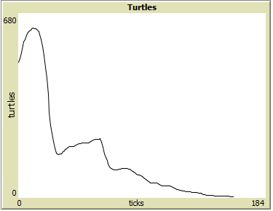

Figure 2.1 Number of turtles with costs and earnings equal, ideal children 1.

As we can see, having enough earnings to sustain children, and having only one child leads to extinction. But having two children is not better, as we discussed previously, because the replacement level is not 2, but 2.1, and we can realize now how much more important this 0.1 difference is; while the extinction takes a bit longer (160 years versus 200 years) it arrives nonetheless. However, the situation changes when turtles wish to have more than 2 children, creating a more stable turtle count in the same amount of time before rising exponentially.

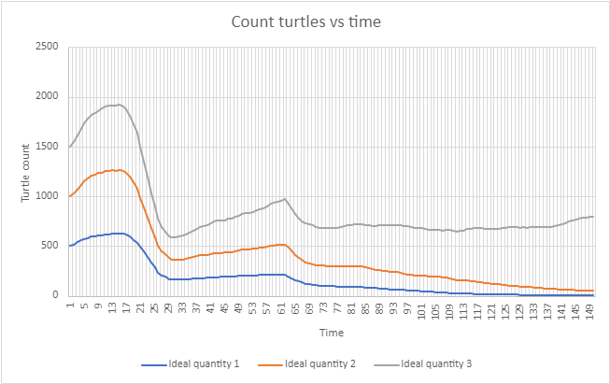

Figure 2.2 Comparison with ideal quantity of children, when all options are affordable.

With this simple verification, we can see similar behaviour from the one demographic research suggests.

## **2.3 Other**

Countries, including the UK, have used migration to boost their population and compensate for falling fertility rates [10]. Many developed countries offer residency to young skilled people between the ages of 18 and 35 [8]. This model offers a button to account for this action, where 50 between these ages are brought.

Another thing we cannot see from the interface is that there is a percentage of turtles that will reproduce even if they do not have sufficient money to afford a child. This number is fixed at 16% and it is based on data about children living in poverty [1].

# **3. Simulation Analysis**

In the next pages, I will explain the simulation and some of the experiments done with it, each of them with their analysis. In the end, in section 3.3, a final analysis that summarizes the findings of the experiments is presented.

## **3.1 Explanation of the simulation**

The control variables are divided into two: the ones that we can apply once in setup, and the ones we can control during the experiment. The reason inflation and income can be changed are that we can’t assume that the inflation and income increase will increase always in the same way, especially if we want to offer policymakers the option to see what would happen if they inject money into the community. We can see these variables in figures 3.1 and 3.2.

The average cost of living, the average cost of a child, average age, and median annual income can be adjusted to simulate a real community. The initial number of people is the number of turtles we start with. There are two control variables that must be assumed, or obtained based on surveys or interviews.

First, the ideal children quantity. If we were only using financial variables, women with high earnings would have a big amount of children, but this is not the case, especially in developed countries. Even if women can afford as many children as they want, there is such a limit. This can be based on personal preference, housing situation, the career path that allows them to have a high income, etc.

Next, the percentage of the population that wishes to be childfree [BROWNE], can be also related to the reasons appointed above. Such people, in a developed country, will not have children under any circumstance.

These variables have a direct impact on TFR, which in turn is in charge of the total count of turtles in the community.

| Figure 3.1 Setup variables | Figure 3.2 Variables that can be updated during the experiment |
| --- | --- |

The response variables are the TFR and the count of total turtles.

## **3.2 Explanation of the result**

Here I will account for some of the experiments I realized. The first one, shown in figure 3.3, tries to reproduce Japan’s situation, while figure 3.4 shows the graph up close. Without adjusting the inflation and income increase during the experiment, and ignoring the first high rise due to the setting of the environment, we can see similar behaviour from the one research expects [20], where the population is halved in 100 years.

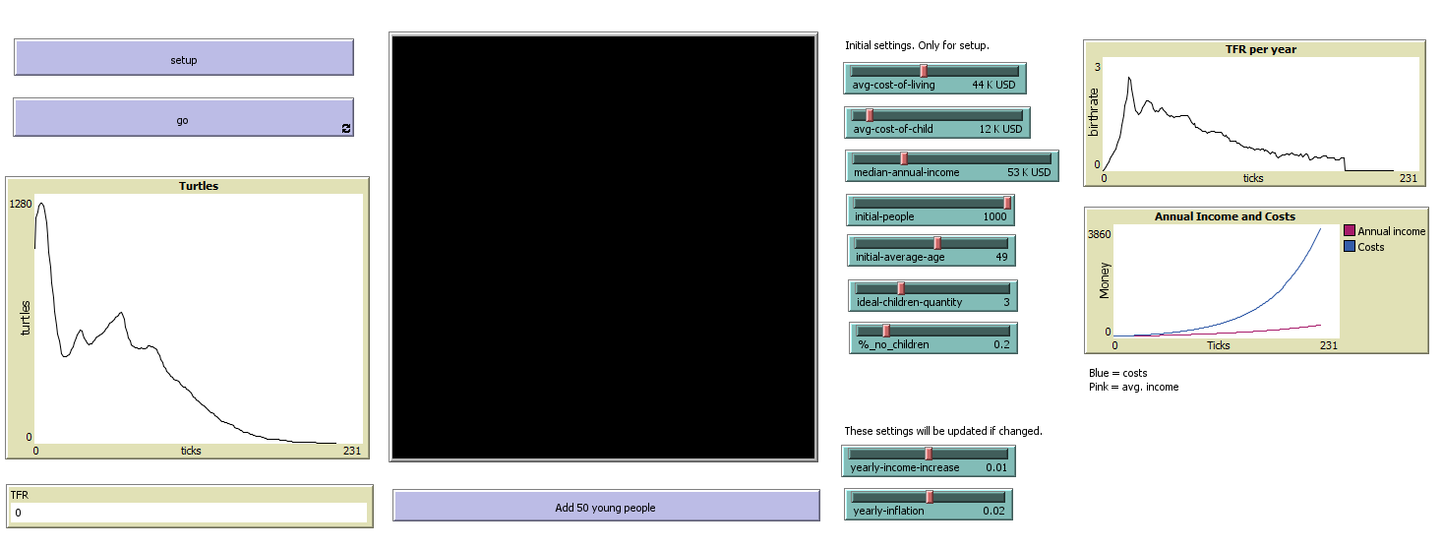

Figure 3.3 Settings based on Japan

During this experiment, Japan’s policies related to migration [GALIN] were simulated by inserting 150 young people.

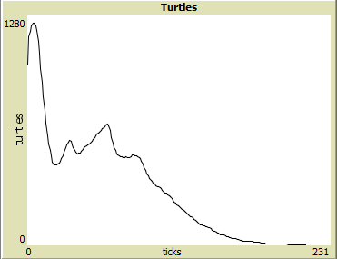

Figure 3.4 Graph of count turtles based on Japan settings

After more experiments, we can see that even if giving the population an increase in salary equal to inflation, it will still go extinct. This is due to the average age in Japan, 48~49. We need to insert more than 100 people for the population not to go extinct; anything less won’t change the main result, especially if the ideal children quantity is less than three. So, for a similar setting that Japan, we could recommend policymakers not only try to give people more money to have children, but focus a lot on boosting immigration.

Next, I tried to reproduce the settings of the US. In their case, I could not find a lot of policies to boost immigration, so people were not added.

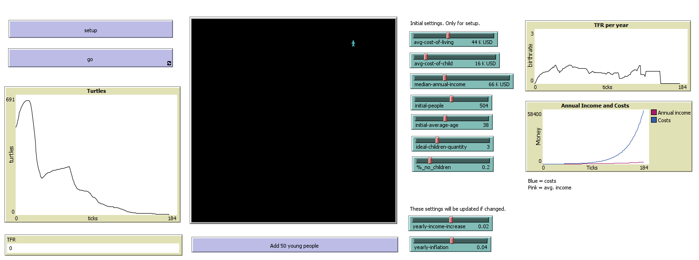

Figure 3.5

In the case of the US, changing the financial variables alone helped them to overcome the declining birthrate, as seen in figure 3.6. If the income has the same increase as the inflation, the TFR is increased. Their age average is 38.

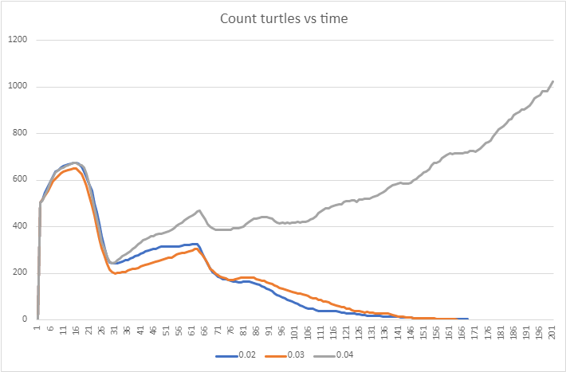

Figure 3.6. Population with inflation fixed at 0.04 but different yearly increase.

If the turtles can afford only two children it will take a long time for the population to go extinct. In figure 3.7 we can appreciate that it takes more than 400 years. This also accounts for the fact that the TFR must be 2.1, as it still could not prevent extinction.

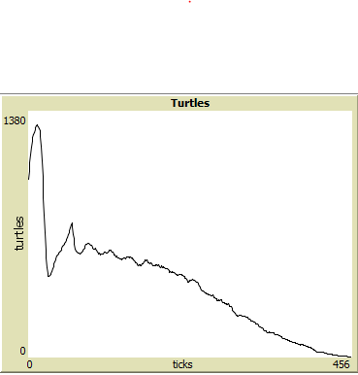

Figure 3.7 Turtles can afford two children.

When turtles can afford more than two children, the TFR increases slowly, as shown in figure 3.8. Even if the TFR increases slowly, we can see how when it passes the 2.1 threshold the population starts increasing exponentially in figure 3.9, and this is also a situation we don’t want in most cases because of its negative effects, such as environmental change. We are still living the consequences of exponential growth in the population [16].

| Figure 3.8 TFR increase when turtles can have more than two children | Figure 3.9 Count increase when turtles can have more than two children |
| --- | --- |

For this report, the last experiment seen in figure 3.10 involves a change in the initial population, from 500 to 1000, with a suitable initial average age (35) and enough money to afford up to 3 children. Even under all the right circumstances, population growth could not be fixed, and eventually, the population went extinct when the density was low (by step 406). Besides being a reflection of population density, this can also address the difficulty of turtles having time to find a suitable partner, which has been cited as a reason people don’t have children in some surveys [9] and some governments are actually getting involved to fix [19].

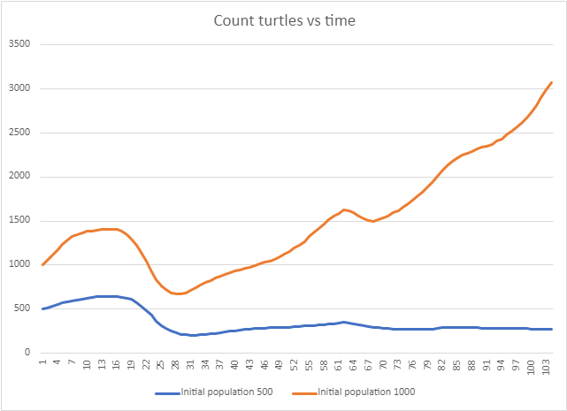

Figure 3.10 Count when start population equals 500 versus 1000. \

## **3.3 Analysis of the result**

Most results obtained from the experiments were expected, and all of them were intuitive, as it’s coherent with the research, and if I try to use settings from a certain place the behaviour is also similar to real life. Findings can be summarized as follows:

* The model confirms that a TFR of 2.1 or more is needed to prevent the decay of population number. TFR of 2 is not enough to cover replacement.
* The initial average age is one of the most important attributes, as it determines whether a community will be able to fix its TFR on its own or will need a migration boost.
* The above is also true for the initial number of turtles. If turtles can’t find a suitable turtle until it’s too late, the TFR cannot be increased.
* Agents would find partners around +/- 10 years their own age even after more than two generations after the initial setting.

# **4. Conclusion**

Establishing a model for human reproduction taking into account social issues is not easy and cannot be replicated using financial insecurity alone (ex. ideal quantity of children). However, it is possible to replicate quite a similar behaviour to real life based on costs/earnings, so financial factors are involved in the decision.

Based on the model, a migration boost is necessary when the average age of the population is more than 40, else no amount of increase in earnings will be enough to improve the TFR. This same idea applies if turtles have a difficult time finding a suitable partner.

Moreover, I think it was interesting to see in action the reasoning behind some governments’ policies regarding immigration, and I think such a model can help both to explain and to seek necessary actions to take regarding TFR.

The code of this model can be found at: <https://github.com/ErickaBermudez/abm-reproduction>

# **5. Reference**

[1] Annie E. Casey Foundation. (n.d.). New Child Poverty Data Illustrate the Powerful Impact of America’s Safety Net Programs - The Annie E. Casey Foundation. https://www.aecf.org/blog/new-child-poverty-data-illustrates-the-powerful-impact-of-americas-safety-net-programs

[2] Blackstone, A. (2014). Childless… or Childfree?, 13(4), 68–70. https://doi.org/10.1177/1536504214558221

[3] Browne, M. (2020). Why the use of terms like “childless” vs “childfree” matters. https://womensagenda.com.au/life/why-terms-like-childless-vs-childfree-matter/

[4] Cleland, J. G. (2008). Trends in human fertility. International Encyclopedia of Public Health, 364–371. https://doi.org/10.1016/B978-012373960-5.00473-1

[5] Dettling, L. J., & Kearney, M. S. (2014). House prices and birth rates: The impact of the real estate market on the decision to have a baby. Journal of Public Economics, 110, 82–100. https://doi.org/10.1016/J.JPUBECO.2013.09.009

[6] De Rose, A. F., Ambrosini, F., Mantica, G., & Terrone, C. (2021). Impact of COVID-19 on birth rate trends in the Italian Metropolitan Cities of Milan, Genoa and Turin. Public Health, 198, 35–36. https://doi.org/10.1016/j.puhe.2021.06.026

[7] Ebenstein, A. (2014). Fertility and Population in Developing Countries. Encyclopedia of Health Economics, 300–308. https://doi.org/10.1016/B978-0-12-375678-7.00110-3

[8] Gallagher, J. (2020). Fertility rate: “Jaw-dropping” global crash in children being born - BBC News. https://www.bbc.com/news/health-53409521

[9] Gan, N. (2021). Chinese millennials aren’t getting married, and the government is worried - CNN. https://edition.cnn.com/2021/01/29/china/china-millennials-marriage-intl-hnk/index.html

[10] Gelin, M. (2020). How Japan Increased Immigration Without Stoking Xenophobia. https://foreignpolicy.com/2020/06/23/japan-immigration-policy-xenophobia-migration/

[11] Haines, M. (2008). Fertility and Mortality in the United States. https://eh.net/encyclopedia/fertility-and-mortality-in-the-united-states/

[12] Haub, C. (2010). Distilled Demographics: The Birth Rate.

[13] Hoffower, H. (2022). More Women Just Don’t Want Children: “Kids Are Expensive and Sticky.” https://www.businessinsider.com/women-dont-want-kids-birth-rate-love-fulfilling-life-2022-4

[14] Housing price inflation, 1967→2022. (n.d.). https://www.in2013dollars.com/Housing/price-inflation

[15] Median vs Average Household Income: What is the Difference Between These Indicators, and How to Interpret Them - Manitoba Collaborative Data Portal. (n.d.). http://www.mbcdp.ca/blog/median-vs-average-household-income-what-is-the-difference-between-these-indicators-and-how-to-interpret-them

[16] Mitchell, J. K., Jeffers, J. M., & Brady, M. B. (2017). The Changing Environment. In Auerbach’s Wilderness Medicine. Elsevier. https://www.clinicalkey.com/#!/content/book/3-s2.0-B9780323359429001194

[17] Ogino, M. (1993). Japanese women and the decline of the birth rate. Reproductive Health Matters, 78–84. https://doi.org/10.1016/0968-8080(93)90064-Z

[18] Park, K. (2005). Choosing childlessness: Weber’s typology of action and motives of the voluntarily childless. Sociological Inquiry, 75(3), 372–402. https://doi.org/10.1111/J.1475-682X.2005.00127.X

[19] Singh, S. (2022). Japan firms adopt AI dating app to help staff find love amid pandemic | The Japan Times. https://www.japantimes.co.jp/life/2022/01/15/lifestyle/japanese-dating-apps-pandemic/

[20] Vollset, S. E., Goren, E., Yuan, C. W., Cao, J., Smith, A. E., Hsiao, T., Bisignano, C., Azhar, G. S., Castro, E., Chalek, J., Dolgert, A. J., Frank, T., Fukutaki, K., Hay, S. I., Lozano, R., Mokdad, A. H., Nandakumar, V., Pierce, M., Pletcher, M., … Murray, C. J. L. (2020). Fertility, mortality, migration, and population scenarios for 195 countries and territories from 2017 to 2100: a forecasting analysis for the Global Burden of Disease Study. The Lancet, 396(10258), 1285–1306. https://doi.org/10.1016/S0140-6736(20)30677-2/ATTACHMENT/0B6EB483-A1ED-41D8-8CF4-7E3821561927/MMC2.PDF

[21] Wage and salary workers in the U.S.: inflation adjusted hourly earnings 1979-2020 | Statista. (n.d.). https://www.statista.com/statistics/185369/median-hourly-earnings-of-wage-and-salary-workers/

[22] Wilensky, U. (1997). NetLogo HIV model. http://ccl.northwestern.edu/netlogo/models/HIV. Center for Connected Learning and Computer-Based Modeling, Northwestern University, Evanston, IL.

[23] Zhang, N., Law, Y. J., Venetis, C. A., Chambers, G. M., & Harris, K. (2021). Female age is associated with the optimal number of oocytes to maximize fresh live birth rates: an analysis of 256,643 fresh ART cycles. Reproductive BioMedicine Online, 42(3), 669–678. https://doi.org/10.1016/J.RBMO.2020.11.010

# **6. Appendix**

As a small appendix, I really enjoyed this project. I think it made me both confident and humble; I really loved Agent Modeling and trying to abstract a problem so we can reproduce it, and I was very happy when I managed to get enough variables to simulate a similar behaviour to the one I wanted. Humble, because I understood how this task was not easy, especially in social settings when there is a lot at play, and understood just how important is to even pick a topic you want to model.

I also really enjoyed working with NetLogo. I was used to common programming languages such as Javascript and Python, and it was very interesting to have to change my mindset in order to program. I cherish a lot my time in this class and I’m really looking forward to using ABM in future projects!